Catalog

**Spirit Guardian(7 variation)**

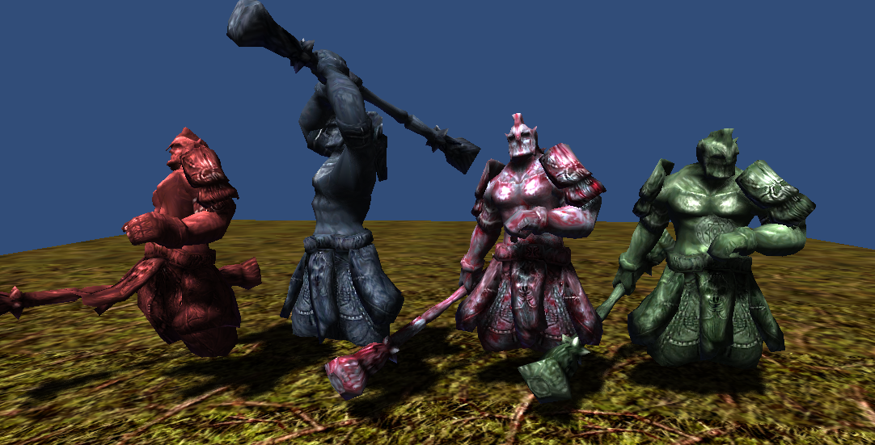

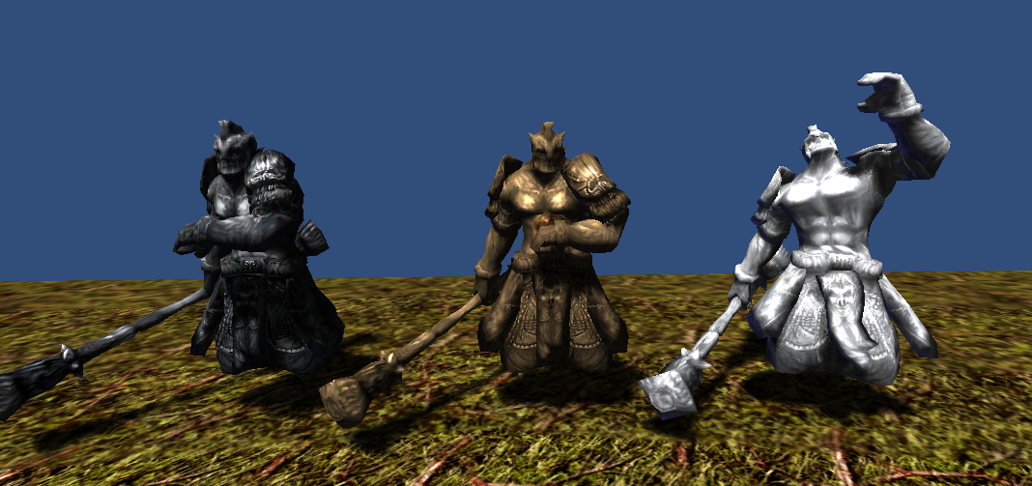

2454 polygons

512x512x24bit 1 texture

5 animations(idle, move, attack, beaten, die)

**Steel Wasp(4 variation)**

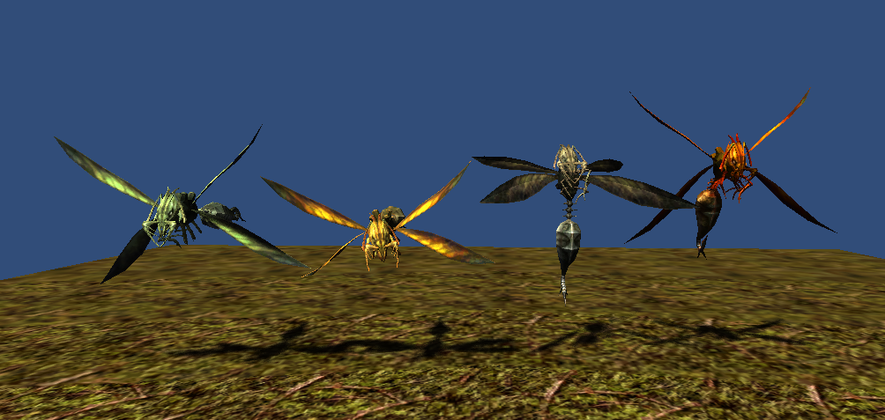

1661 polygons

512x512x24bit 1 texture

6 animations(idle, move, attack1, attack2, beaten, die)

**FishMan(2 variation)**

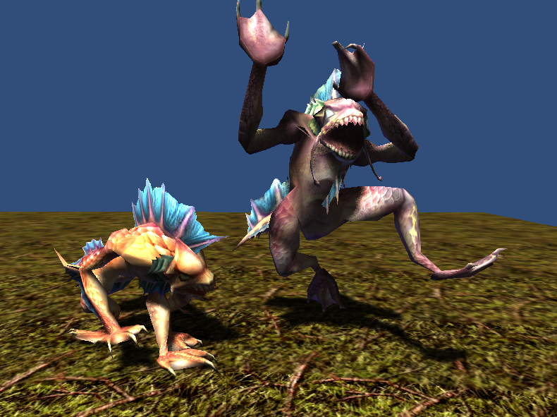

1568 polygons (runner 1824 polygons)

512x512x32bit 1 texture

5 animations(idle, move, attack, beaten, die)

**Ant Worker(5 variation)**

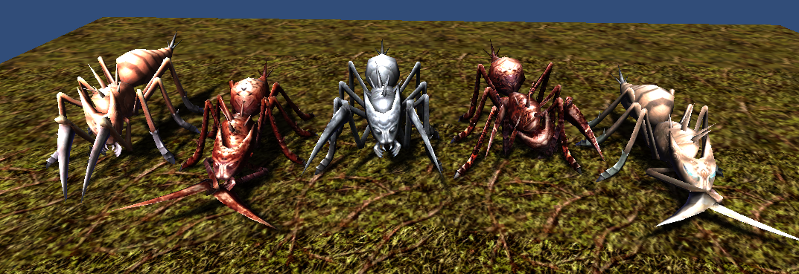

1000 polygons

512x512x32bit 1 texture

6 animations(idle, move, attack1, attack2, beaten, die)

**Thank you for download.**

**Contact**

Homepage : http://www.studioez.net

E-Mail : admin@studioez.net